What will be the output of the following program? Ans. main
public class JavaThreadsQuiz{
public static void main(String[] args){
String name = Thread.currentThread().getName();
System.out.println(name);
}
}
What is the purpose of join method? 3
The purpose of the join() method in Java is to make one thread wait for another thread to finish its execution before continuing.
Simple terms:
- When you call thread.join() on a thread, the current thread pauses and waits for that thread to complete before continuing.
- This is useful when you want to ensure that a particular thread has finished before the program moves on.
Example:
Thread t1 = new Thread(() -> {
System.out.println("Thread 1 running");
});
t1.start();
t1.join(); // main thread waits here until t1 finishes
System.out.println("Main thread continues after t1");

Purpose | Description
Wait for thread to finish | Current thread waits for another thread to complete before continuing
Synchronize threads | Helps control order of execution between threads
Avoid race conditions | Ensures dependent threads complete before proceeding

Dead thread can be accessed using=== ans. none of these
a) start ( ) b) notify ( ) c) recreate ( ) d) none of these.

which one of the following is a limitation of subclassing the Thread class ?
d) You cannot subclass any other class.

The method used in Java which waits for the thread to die is d) join()

Under which circumstances will a thread stop?
Select all valid answers.
(A) The run( ) method that the thread is executing ends

What is multithreading ?
Multithreading is a Java feature that allows the concurrent execution of two or more parts of a program for maximum utilization of the CPU. Each part of such a program is called a thread. So, threads are lightweight processes within a process.
In which class is the wait() method defined ? d) Object.
Summary:
- wait() → Object class
- start(), sleep(), etc. → Thread class
- run() → Runnable interface (implemented in Thread)

Lifecycle and States of a Thread in Java
Obtaining a Thread's State
A thread can exist in a number of different states. We can obtain the current state of a thread by calling the getState() method defined by Thread. It is shown here:
Thread.State getState()
It returns a value of type Thread.State that indicates the state of the thread at the time at which the call was made. State is an enumeration defined by Thread.
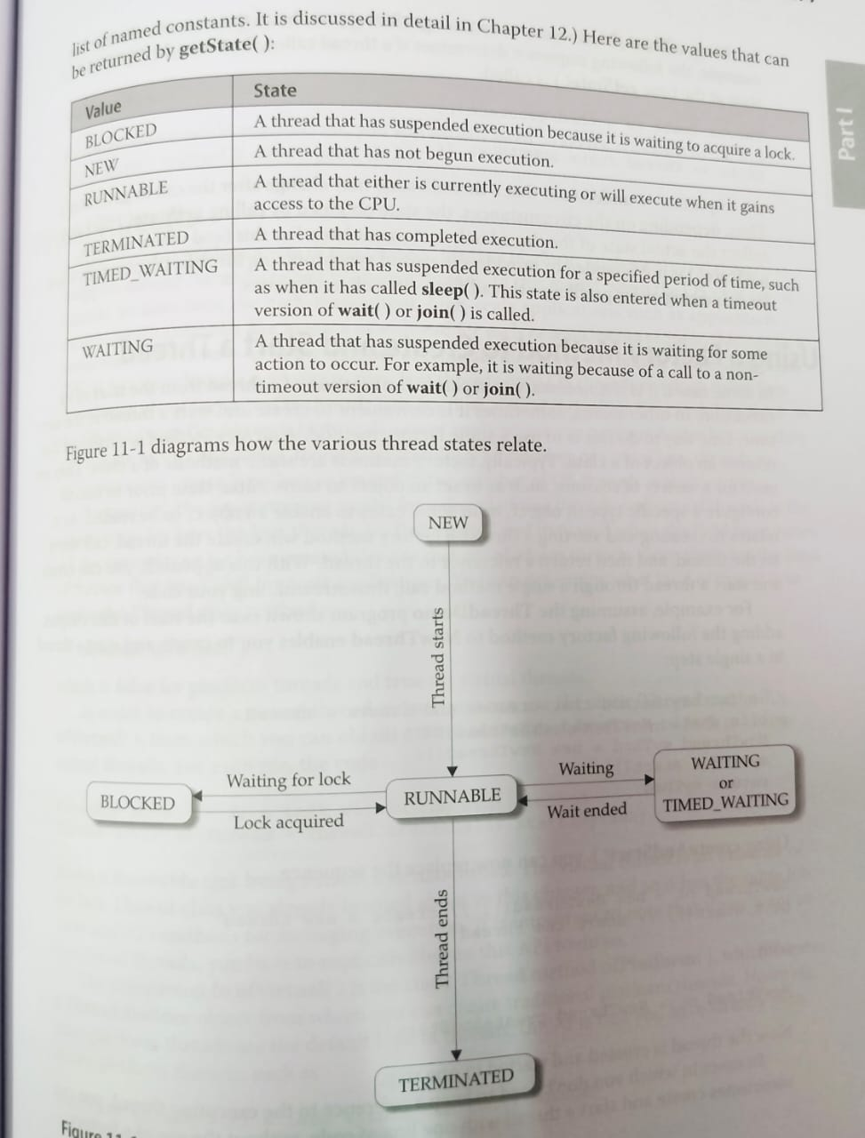

A thread in Java can exist in any one of the following states at any given time. A thread lies only in one of the shown states at any instant:
- New State
- Runnable State
- Blocked State
- Waiting State
- Timed Waiting State
- Terminated State
The diagram below represents various states of a thread at any instant:
Life Cycle of a Thread
There are multiple states of the thread in a lifecycle as mentioned below:
- New Thread: When a new thread is created, it is in the new state. The thread has not yet started to run when the thread is in this state. When a thread lies in the new state, its code is yet to be run and has not started to execute.
- Runnable State: A thread that is ready to run is moved to a runnable state. In this state, a thread might actually be running or it might be ready to run at any instant of time. It is the responsibility of the thread scheduler to give the thread, time to run. A multi-threaded program allocates a fixed amount of time to each individual thread. Each and every thread get a small amount of time to run. After running for a while, a thread pauses and gives up the CPU so that other threads can run.
- Blocked: The thread will be in blocked state when it is trying to acquire a lock but currently the lock is acquired by the other thread. The thread will move from the blocked state to runnable state when it acquires the lock.
- Waiting state: The thread will be in waiting state when it calls wait() method or join() method. It will move to the runnable state when other thread will notify or that thread will be terminated.
- Timed Waiting: A thread lies in a timed waiting state when it calls a method with a time-out parameter. A thread lies in this state until the timeout is completed or until a notification is received. For example, when a thread calls sleep or a conditional wait, it is moved to a timed waiting state.
- Terminated State: A thread terminates because of either of the following reasons:
  - Because it exits normally. This happens when the code of the thread has been entirely executed by the program.
  - Because there occurred some unusual erroneous event, like a segmentation fault or an unhandled exception.

Create Threads
Thread can be referred to as a lightweight process. Thread uses fewer resources to create and exist in the process; thread shares process resources. The main thread of Java is the thread that is started when the program starts. The slave thread is created as a result of the main thread. This is the last thread to complete the execution.
A thread can programmatically be created by:
- Implementing the Runnable interface.
- Extending the Thread class.
Runnable Interface
Any class with instances that are intended to be executed by a thread should implement the Runnable interface. The Runnable interface has only one method, which is called run().
Use Case: It is suitable for cases where you want to separate the task from the thread management. Also, Runnable is a interface so allows us to perform multiple inheritance.
Thread class
The Thread class provides constructors and methods for creating and operating on threads. The thread extends the Object and implements the Runnable interface.
It starts a newly created thread. Thread moves from new state to runnable state when it gets a chance, executes the target run() method
Use Case: Suitable for simple applications for creating a thread that performs a specific task.

Java Thread Priority in Multithreading
Priorities in Threads in Java is a concept where each thread has a priority in layman’s language one can say every object has priority here which is represented by numbers ranging from 1 to 10, and the constant defined can help to implement which are mentioned below.
Constant | Description
public static int NORM_PRIORITY | Sets the default priority for the Thread. (Priority: 5)
public static int MIN_PRIORITY | Sets the Minimum Priority for the Thread. (Priority: 1)
public static int MAX_PRIORITY | Sets the Maximum Priority for the Thread. (Priority: 10)

1. Setting Thread Priority
You can set a thread’s priority using the setPriority(int priority) method:
java
CopyEdit
Thread t1 = new Thread();
t1.setPriority(Thread.MAX_PRIORITY); // sets priority to 10
2. Getting Thread Priority
You can retrieve it using getPriority():
java
CopyEdit
int priority = t1.getPriority();
System.out.println(priority); // prints 10
Example
class MyThread extends Thread {
public void run() {
System.out.println("Running thread: " + Thread.currentThread().getName() +
" with priority: " + Thread.currentThread().getPriority());
}
}

public class Main {
public static void main(String[] args) {
MyThread t1 = new MyThread();
MyThread t2 = new MyThread();
MyThread t3 = new MyThread();

t1.setPriority(Thread.MIN_PRIORITY); // 1
t2.setPriority(Thread.NORM_PRIORITY); // 5
t3.setPriority(Thread.MAX_PRIORITY); // 10

t1.start();
t2.start();
t3.start();
}
}

The synchronized Keyword in Java
The synchronized keyword in Java is used to control access to a block of code or method by multiple threads. It ensures that only one thread at a time can execute a synchronized method or block on the same object.
Purpose of synchronized
In a multithreaded environment, multiple threads may try to access shared resources (like variables, files, or methods) simultaneously. This can lead to data inconsistency or race conditions.
The synchronized keyword:
- Prevents simultaneous access to critical sections by multiple threads.
- Ensures thread safety when working with shared resources.

What is Synchronization in Java?
Synchronization is a mechanism that ensures that only one thread can access a block of code or method at a time. It's primarily used in multithreading to protect shared resources from concurrent access.

Why Use synchronized?
- To prevent thread interference.
- To ensure visibility and consistency of shared variables.
- To maintain atomicity in operations.
synchronized Can Be Used In:
- Instance methods
- Static methods
- Code blocks

Example: Synchronized Method
class AppleCounter {
int apples = 0;
// This method is synchronized, so only one thread can use it at a time
public synchronized void addApple() {
apples++;
}
public int getApples() {
return apples;
}
}

public class Main {
public static void main(String[] args) throws InterruptedException {
AppleCounter counter = new AppleCounter();

// Thread 1 adds 1000 apples
Thread t1 = new Thread(() -> {
for (int i = 0; i < 1000; i++) {
counter.addApple();
}
});

// Thread 2 also adds 1000 apples
Thread t2 = new Thread(() -> {
for (int i = 0; i < 1000; i++) {
counter.addApple();
}
});

t1.start();
t2.start();

t1.join(); // Wait for t1 to finish
t2.join(); // Wait for t2 to finish

System.out.println("Total apples: " + counter.getApples());
}
}

There are two ways to create a new thread of execution. One is to declare a class to be a subclass of the Thread class. The other way to create a thread is to declare a class that implements the Runnable interface. That class then implements the run method.
Illustrate with an example how to create a thread using thread class and also using Runnable interface. 7

Creating a Thread by Extending the Thread Class
You create a new class that extends Thread and override the run() method. Then, create an instance of your class and call start().
Example:
// Extend Thread class
class MyThread extends Thread {
public void run() {
System.out.println("Thread running by extending Thread class");
}
}

public class Main {
public static void main(String[] args) {
MyThread t = new MyThread();
t.start(); // Start the new thread
}
}

2️⃣ Creating a Thread by Implementing the Runnable Interface
You create a class that implements Runnable, implement the run() method, then create a Thread object passing the Runnable instance, and call start().
Example:
// Implement Runnable interface
class MyRunnable implements Runnable {
public void run() {
System.out.println("Thread running by implementing Runnable interface");
}
}

public class Main {
public static void main(String[] args) {
MyRunnable r = new MyRunnable();
Thread t = new Thread(r);
t.start(); // Start the new thread
}
}

🔑 Key Differences:
Feature | Extending Thread | Implementing Runnable
Class inheritance | You extend Thread | You implement Runnable
Can extend another class | No (since Java supports single inheritance) | Yes (can extend another class)
Separation of task and thread | Less flexible | More flexible
Used more often in practice | Less common | Preferred way

What is a Thread?
A thread in Java is a lightweight unit of execution within a program. It allows you to perform multiple tasks at the same time (concurrently).
- Every Java program starts with a main thread.
- You can create multiple threads to perform background tasks without interrupting the main program.

Two Methods to Stop a Thread
In Java, there are two main ways to stop or end a thread:

1. Using stop() method (❌ Deprecated)
- The stop() method immediately terminates a thread.
- But it's unsafe and deprecated because it can leave shared data in an inconsistent state.
Thread t = new Thread();
t.stop(); // Not recommended

2. Using a flag or interrupt mechanism (✅ Safe and recommended)
This is the preferred way to stop a thread.
a) Using a boolean flag:
class MyThread extends Thread {
private boolean running = true;

public void run() {
while (running) {
System.out.println("Thread is running...");
}
}
public void stopThread() {
running = false;
}
}

b) Using interrupt() and checking isInterrupted():
class MyThread extends Thread {
public void run() {
while (!isInterrupted()) {
System.out.println("Thread is running...");
}
}
}

MyThread t = new MyThread();
t.start();
t.interrupt(); // requests the thread to stop

Deadlock in Java
A deadlock occurs when two or more threads are waiting for each other to release resources, and none can proceed.

Example:
class A {
synchronized void methodA(B b) {
System.out.println("Thread 1: Locked A, trying to lock B...");
try { Thread.sleep(100); } catch (Exception e) {}
b.methodB();
}

synchronized void methodAOnly() {
System.out.println("Thread 1: Inside A.methodAOnly");
}
}

class B {
synchronized void methodB(A a) {
System.out.println("Thread 2: Locked B, trying to lock A...");
try { Thread.sleep(100); } catch (Exception e) {}
a.methodAOnly();
}

synchronized void methodB() {
System.out.println("Thread 2: Inside B.methodB");
}
}

public class DeadlockExample {
public static void main(String[] args) {
A obj1 = new A();
B obj2 = new B();

// Thread 1: holds lock on obj1, tries to get obj2
Thread t1 = new Thread(() -> obj1.methodA(obj2));

// Thread 2: holds lock on obj2, tries to get obj1
Thread t2 = new Thread(() -> obj2.methodB(obj1));

t1.start();
t2.start();
}
}

Inter-thread Communication in Java
Inter-thread communication means threads talking to each other — especially when one thread needs to wait for a signal from another thread.
Java provides three main methods (defined in the Object class) for inter-thread communication:

🔧 Key Methods:
Method | Purpose
wait() | Makes the current thread wait until another thread calls notify() or notifyAll()
notify() | Wakes up one waiting thread
notifyAll() | Wakes up all waiting threads

Example:
class Data {
synchronized void send() {
System.out.println("Sending...");
notify(); // notify the waiting thread
}

synchronized void receive() {
try { wait(); } catch (Exception e) {}
System.out.println("Received.");
}
}

public class Test {
public static void main(String[] args) {
Data d = new Data();
new Thread(() -> d.receive()).start();
new Thread(() -> d.send()).start();
}
}

1️. Extending the Thread class
class MyThread extends Thread {
public void run() {
System.out.println("Thread running");
}
}
- You create a new class that extends Thread and override the run() method.
- Then you start the thread with .start().
2️. Implementing the Runnable interface
class MyRunnable implements Runnable {
public void run() {
System.out.println("Thread running");
}
}
- You implement Runnable and pass the object to a Thread:
Thread t = new Thread(new MyRunnable());
t.start();
Why Two Ways?
Java gives you both so that:
- If you don't need to extend another class, extending Thread is fine.
- If you need to extend another class, use Runnable (because Java doesn’t support multiple inheritance).
- Runnable separates task from thread execution, making code more flexible and reusable.

✅ Which is Better?
Using Runnable is generally better.
✔️ Advantages of Runnable:
- Allows you to extend another class.
- Promotes separation of task and thread.
- Works well with thread pools and executors.
- Makes code cleaner and more flexible.
Write a program in JAVA that creates a Child Thread of main using Runnable interface and uses the following methods: (i) getName() (ii) setName() (iii) setPriority()

class MyRunnable implements Runnable {
public void run() {
System.out.println("Thread name: " + Thread.currentThread().getName());
System.out.println("Thread priority: " + Thread.currentThread().getPriority());
}
}

public class Test {
public static void main(String[] args) {
Thread t = new Thread(new MyRunnable());
t.setName("ChildThread");
t.setPriority(8);
t.start();

System.out.println("Main thread name: " + Thread.currentThread().getName());
}
}

